Comparison of Region Based on Sales

1. A hierarchy called Location for the variable Country.

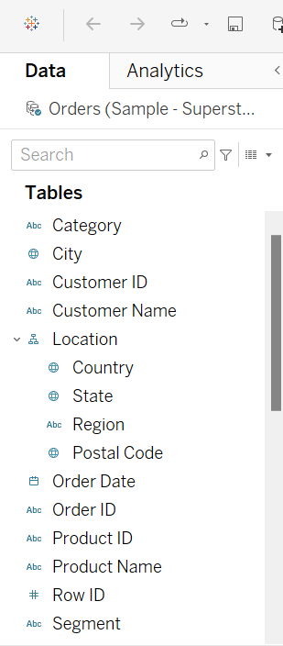

2.Two parameters: Primary Region and Secondary Region with all regions listed in them. Here, primary and secondary region are the two regions where the sales are being compared.

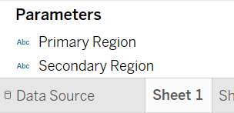

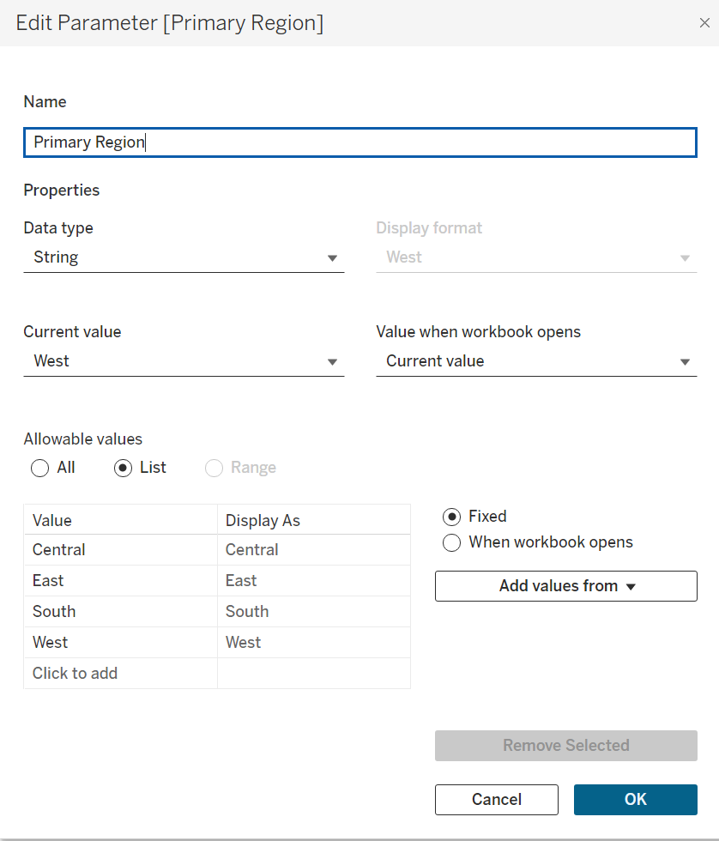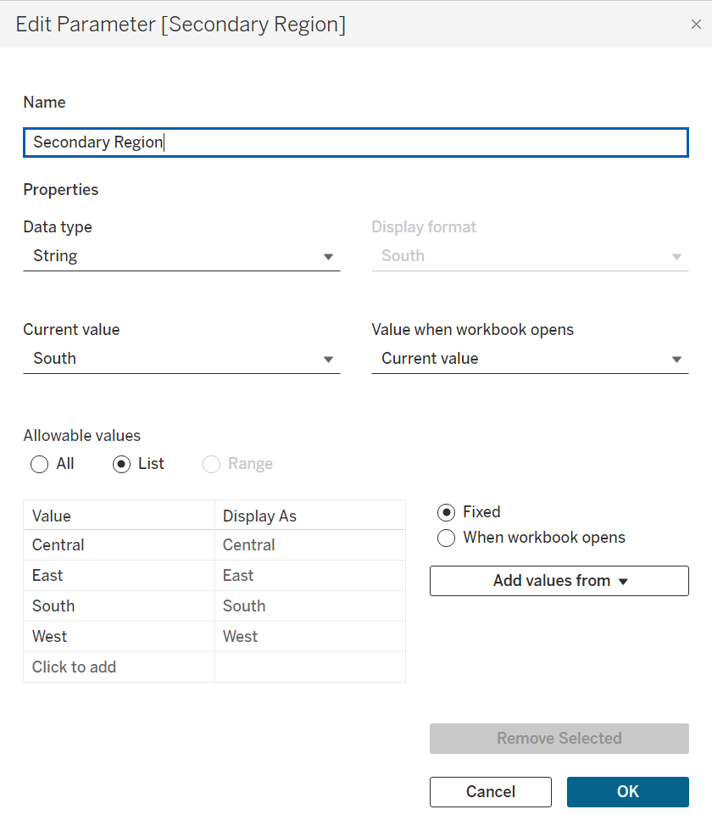

1. Comparison of the Region wise sales.

Central VS East

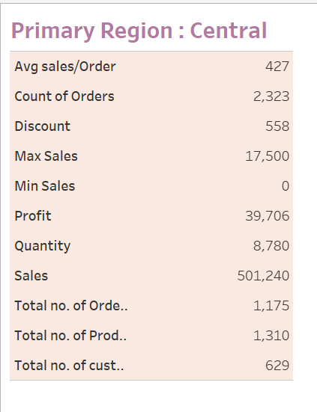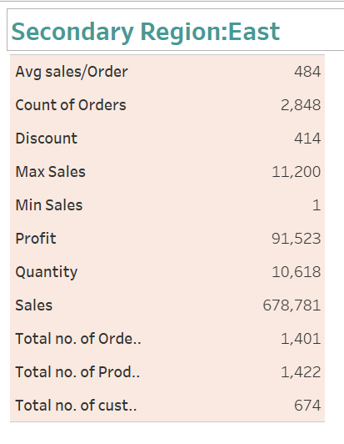

1. Comparison of the Region wise sales.

East VS West

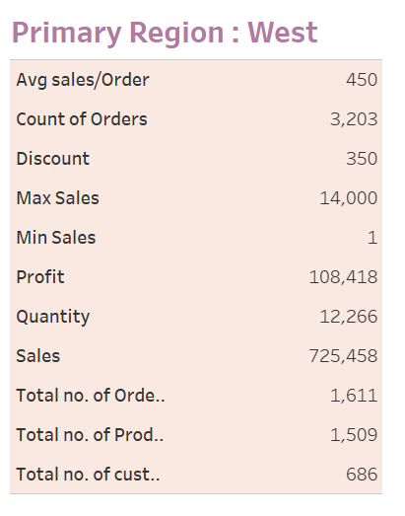

West VS South

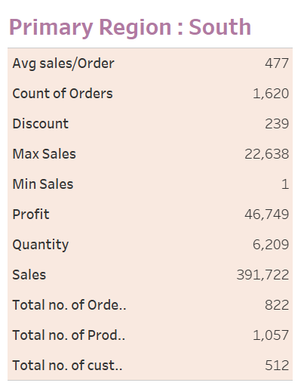

1. Created a Calculated Field and named it as the First Order Date.

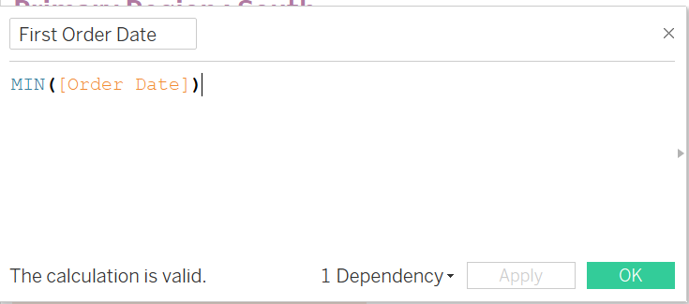

1. Dashboard Created in which the following details of Primary Region and Secondary Region were Displayed Such As
   1. First Order Date
   2. Total Sales
   3. Average Sales per Order
   4. No. of Customers
   5. No. of Orders
   6. No. of Products in Sale

